Work Education Lesson 2 & 3: 27th July /3rd August- Subject selection prep work
This will be a continuation from last week’s class for students needing more time. I have also added an additional sheet for students who would like further research.

Learning Intention-
- Students investigate their subject selection for 2027 and complete the subject selection form
Success Criteria-
- Students plan for their subjects for 2027
- Students complete their subject selection form ready for counselling session on the 12th of August – this is ESSENTIAL and must be completed prior to attending the counselling session

Before completing the following, please revisit Morrisby Profile completed last year - Morrisby here

- Students to explore and work through the VTAC year 10 guide - links can be accessed via website YR 10 VTAC GUIDE OR Kew High careers website - Kew High School Careers Website

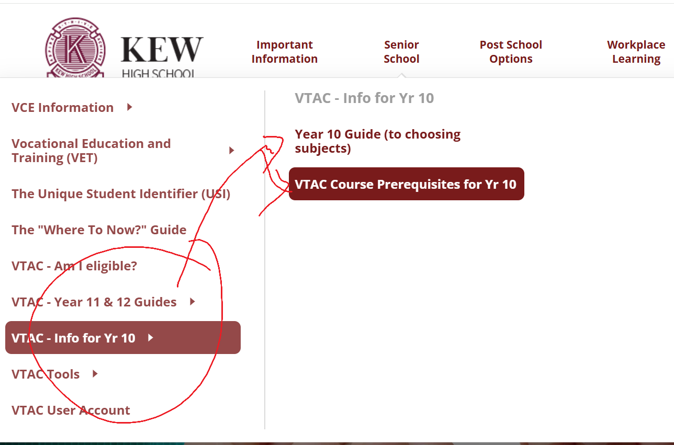

- Students to explore Prerequisites 2029 : Prerequisites for 2029 and the Matrices document saved in class resources (resource also under Teams and Work Education resources also here- MATRICES 2026.pdf )

- Using course search (VTAC) is also highly recommended. Link - VTAC course search

How to use CourseSearch fact sheet

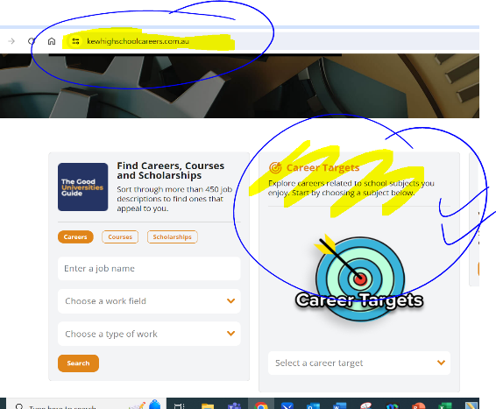
- Students can also play around with school career website / Career Targets to explore different occupations and further related information

- Our school website also has further information which is recommended for students to explore.

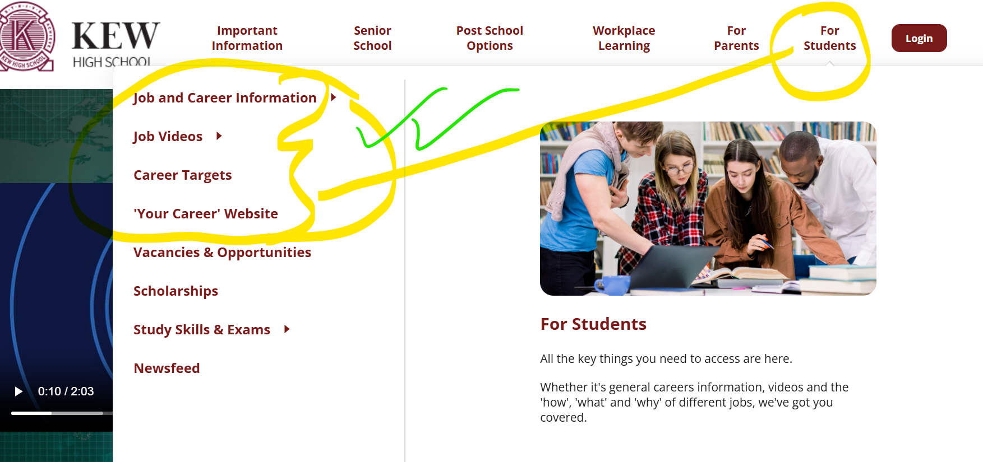

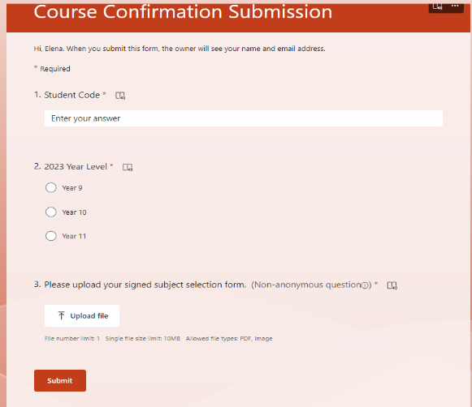
Year 10 students will be required to attend Course counselling on the 12th of August (this is to discuss possible subject selection) which will then be submitted by the 15th of August.

Suggested worksheets for all students:
- Identifying my strengths and interests
- Setting and reaching my goals
- My tertiary course research plan
- Choosing my year 11 and 12 studies

- For students who are thinking of an apprenticeship or straight out to work (VM) :
- Explore - Is an apprenticeship right for you? | ReachOut Australia (clicking on all the links in this site)
- Also have a look at - Career Interest Activity booklet
- Students interested in VM need to complete a VET course: see link below https://www.vic.gov.au/vet-pathways-schools OR VCE-VET-programs

Remember
There is no "perfect" combination of VCE subjects. The best choices are those that:
- match your interests and strengths
- challenge you appropriately
- keep future options open
- support your wellbeing and success.
Choose subjects because they are a good fit for you, not because your friends are choosing them.

